**Backend Task 2**

College: K L University

Roll No: 2000031114

Name: Y Dhanush Kumar

**Develop Number Management HTTP Microservice**

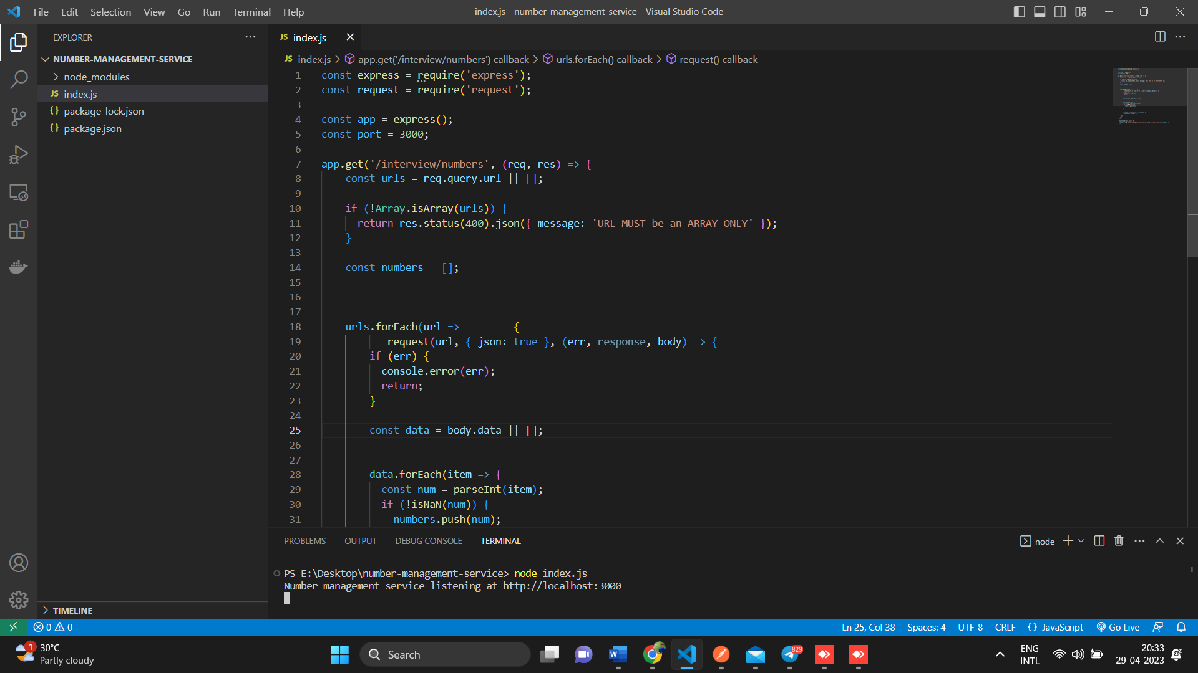

**index.js**

const express = require('express');

const request = require('request');

const app = express();

const port = 3000;

const TIMEOUT = 500;

app.get('/interview/numbers', (req, res) => {

  const urls = req.query.url || [];

  const numbers = new Set();

  let remaining = urls.length;

  urls.forEach(url => {

    request({ url, json: true, timeout: TIMEOUT }, (err, response, body) => {

      if (err) {

        console.error(`Error retrieving data from ${url}:`, err);

      } else if (response.statusCode !== 200) {

        console.error(`Unexpected status code ${response.statusCode} when retrieving data from ${url}`);

      } else {

        const data = body.numbers || [];

        data.forEach(item => {

          const num = parseInt(item);

          if (!isNaN(num)) {

            numbers.add(num);

          }

        });

      }

      remaining--;

      if (remaining === 0) {

        res.json({ numbers: Array.from(numbers).sort((a, b) => a - b) });

      }

    });

  });

});

app.listen(port, () => {

  console.log(`Number management service listening at http://localhost:${port}`);

});

<http://localhost:3000/interview/numbers?url=http://104.211.219.98/numbers/primes&url=http://abc.com/fibo>

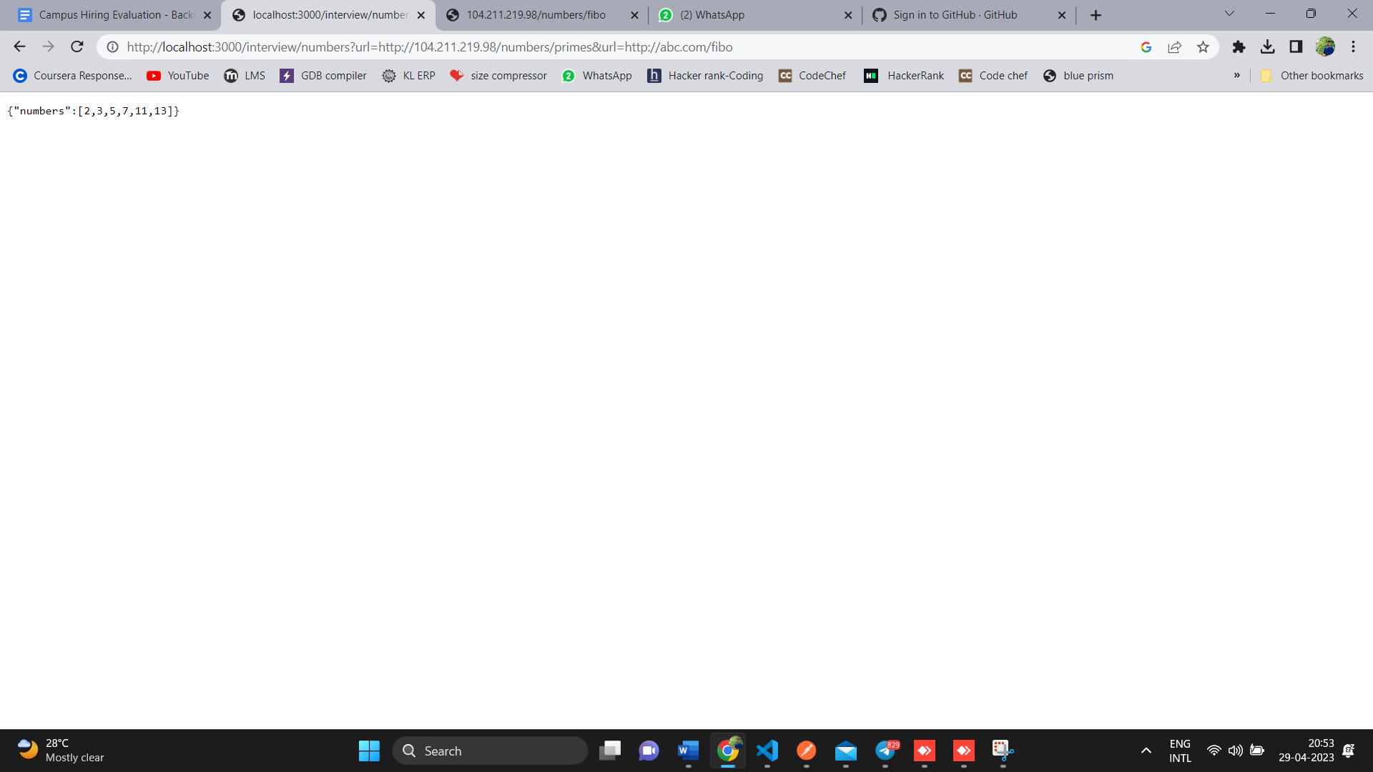

http://localhost:3000/interview/numbers?url=http://104.211.219.98/numbers/fibo&url=http://abc.com/fibo

